Research: what can my local councillors do?
There's a local election coming up ... why is this important to me?
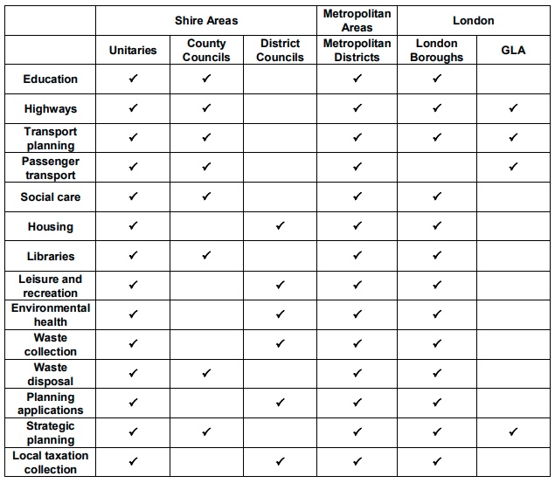
https://votingcounts.org.uk/what-do-local-councillors-do
Which of these things are important to me?
What do these things actually mean? Look on line, and find an example of what is included under each heading. Examples:
- Highways – a pot hole, a streetlight, a speed bump to slow cars down and make it safer for me to walk home after school.
- Leisure & recreation – the park, the sports centre
- Waste collection – the bins
- Waste disposal – recycling
- Education – my school
- Libraries – the books I want to read
Which of these things would I like to be different?
Be specific. Give details.
For example, not just ‘the books I want to read’. Which books exactly do you want to see in the library?
Understanding: Lobbying and persuading
Could I get my councillor to change the things which I would like to be different?
- When is the best time to get someone to promise something?
Answer: when they want something from me, and they will promise to do something for me in return.
[Example: my mum might promise that I can have an ice cream at the end of the week, if I agree that I will be well behaved and do all my homework and keep my room really tidy for all of that week.]
- What does my councillor (or the candidate to be my councillor) want from me?
Answer: for me to get my parents to vote for them.
So, can I get my councillor to agree to change the things that I want to be better, if they are elected, in return for me persuading my parents to vote for them?
How do I let my councillor know what I want?
[Because if they don’t know that you want it, then they can’t agree to change it!]
- write a letter
- go to a surgery
- invite the councillor to my assembly
Making a Plan
Let's set up a plan to get my councillor (or the candidates to be my councillor) to do something which we want.
- First - what do we want to be different?
- Next - let's put some details on that: How much will it cost? How long will it take?
- After that - let's put together a class presentation, explaining what we want - perhaps a poster, a video, a letter.
Now, how can we present our request for change to our councillor (or the candidates to be our councillor)?
- Shall we invite the candidates to our assembly, to listen to our presentation?
Taking Action
Now that we have a plan … let’s do it!
- Let’s make the best presentation we can.
- Let’s invite the candidates to be our councillor to come and listen to our presentations.
- Let’s get the candidates to agree to our request for change.
Alternative to inviting candidates
Stand for election on a platform of promising to make the change you want to see in your local area (e.g., getting more lighting on the street outside your school for winter evenings)

